UWA’s Convenience Store

SUBMITTED BY:
Sibla, Josua A.

BSCS 2E

January 2026
INTRODUCTION

UWA's Super Convenience Store Ordering System is a web-based application created to help manage orders in my store efficiently.
This system allows customers to:
- Enter their personal information like name, address, and contact number.
- Browse products organized by categories such as Drinks, Biscuits, Coffee, Chips, Toiletries, and Alcohol.
- Add multiple products to their order and see the quantity, price, and subtotal.
- View the total amount of their order and finish it easily.
Purpose:
The system was developed to simplify the ordering process in my store, reduce manual errors, and provide a simple, digital way to keep track of orders. It also serves as a beginner-friendly project using PHP, MySQL, HTML/CSS, and basic JavaScript.

DATABASE DESIGN

The database of UWA's Super Convenience Store Ordering System is named order_system. It stores all information about customers, products, and orders.
The database consists of three main tables:
1. customers Table
This table stores information about each customer.
Field | Type
id | INT PK
name | VARCHAR
Address | VARCHAR
Contact | VARCHAR

2. products Table
This table stores all products available in the store, including their category and price.
Field | Type
id | INT PK
name | VARCHAR
price | DECIMAL
Category | VARCHAR

3. orders Table
This table stores all customer orders. Each row represents one product ordered.
Field | Type
id | INT PK
customer_id | INT FK
product_name | VARCHAR
price | DECIMAL
Quantity | INT
Subtotal | DECIMAL

Relationships
- One customer can have multiple orders (1-to-many relationship).
- Products are stored separately in the products table, but the orders table saves product name and price at the time of ordering.
- orders.customer_id is a foreign key linking to customers.id to identify which customer made the order.
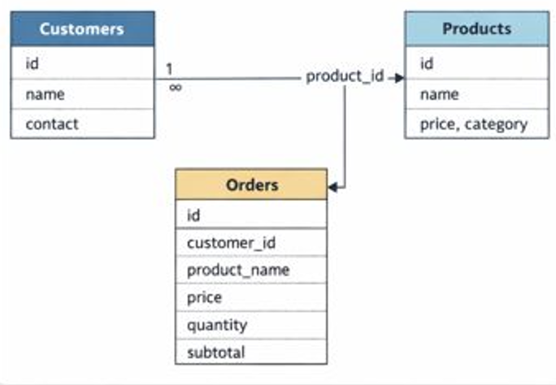

Challenges and Learning

During the development of UWA's Super Convenience Store Ordering System, several challenges were encountered. One of the main challenges was displaying products dynamically under their correct categories. Initially, products either appeared all at once or were hidden incorrectly. Using JavaScript collapsible buttons helped solve this problem, allowing each category to expand and show its products when clicked. Another challenge was saving orders correctly in the database. At first, orders were not being stored properly, so debugging the PHP code and checking the database table structure was necessary. Calculating subtotals for each product and the total amount for the order was also tricky, and learning to loop through orders in PHP helped solve this. Finally, designing the user interface to be organized, readable, and easy to use required some trial and error.
From this project, many useful lessons were learned. I gained practical experience connecting PHP with MySQL to store and retrieve data, and I learned how to create relationships between tables such as customers, products, and orders. I also improved my HTML and CSS skills by creating forms, styling pages, and adding background images. Using JavaScript for interactivity taught me how to make collapsible product categories, improving the user experience. This project also helped me develop problem-solving and debugging skills, especially when orders were not saving correctly or totals were calculated incorrectly. Overall, I learned how to manage a beginner-level web application from start to finish, including customer input, product selection, order summary, and completing orders.

